Since inception, CLINTERPOL has tried its best to deliver professional and cutting edge services to its clients. In so doing, CLINTERPOL have been blessed to have attracted some of the leading local and global institutions and offered them great services.



**MPESA FOUNDATION ACADEMY**

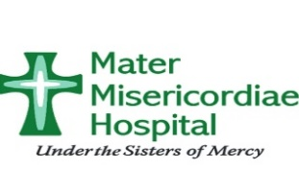

**MARTER MISERICORDIA HOSPITAL**



**KINGS WAY TYRES LIMITED**



**SISU GLOBAL HEALTH**



**PG SECURITY**



**QARIBU INN HOTEL**



**NATIONAL GUN OWNERS ASSOCIATION ORGANISATION**



**VICTORIA COMMERCIAL BANK**

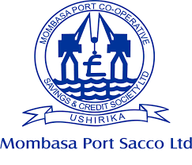

**MOMBASA PORT CO-OPERATIVE**

**SAVINGS & CREDIT SOCIETY LIMITED**

**HARAMBEE SACCO SOCIETY LIMITED**



**THE NAIROBI CLUB**